**Teaching Single-digit Multiplication with Multiple Representations**

**Multiple Representations**

* Students use objects, pictures, and drawings to complete mathematics tasks and solve equations.
  + Students can physically show and see numbers, operations, etc…
  + Mathematical language is explicit with hands-on and visual supports
* The concrete-representational-abstract sequence (CRA) uses multiple representations across a sequence of lessons
  + Concrete: solve equations with objects
  + Representational: solve equations with pictures and drawings
  + Abstract: solve equations with numbers and symbols only

**Application to Single-digit Multiplication**

* Students solve single-digit multiplication equations by making equal-sized groups. One multiplier tells how many groups and the other tells what is in each group.

**Concrete Instruction**:

Fill arrays with objects. Columns are groups, each filled with the same amount of objects.

**3 x 4 =**

Use objects such as plates and fill each with same amount of counters.

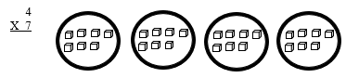

**Representational Instruction**:

Use arrays. Shade picture of array to show equal groups.

4 groups

**4 x 7 =**

of 7

Use drawings with horizontal lines showing groups and short vertical lines to show how many are in each group.

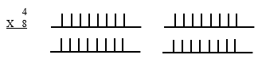

* Once students consistently solve equations with physical (concrete) and visual (representational) supports, they learn a mnemonic strategy that will help them solve equations at the abstract level.
  + **D**iscover the sign
  + **R**ead the problem
  + **A**nswer or draw and check
  + **W**rite the answer

**Abstract Instruction:** Use DRAW strategy to solve equations. Use games and other practice activities to build fluency. Focus on **engaging** practice activities.

**SIM materials include CRA single-digit multiplication.**

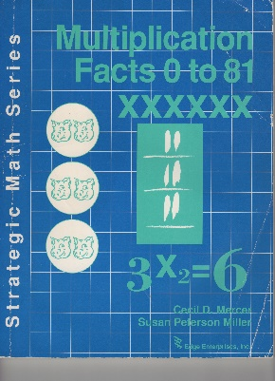Mercer, C. D., & Miller S. P. (1992). *Strategic math series: Multiplication facts 0-81*. KUCRL. <https://sim.ku.edu/multiplication-facts-0-81>