Resources for the Practice of Scientific Argumentation: Gaming and Social Media
Marilyn Ault, Amber Rowland & Jana Craig-Hare
2014 International SIM Conference - July 16, 2014

Scientific Argumentation Articles:
Engaging Students in the Scientific Practices of Explanation and Argumentation. Reiser, Berland & Kenyon.
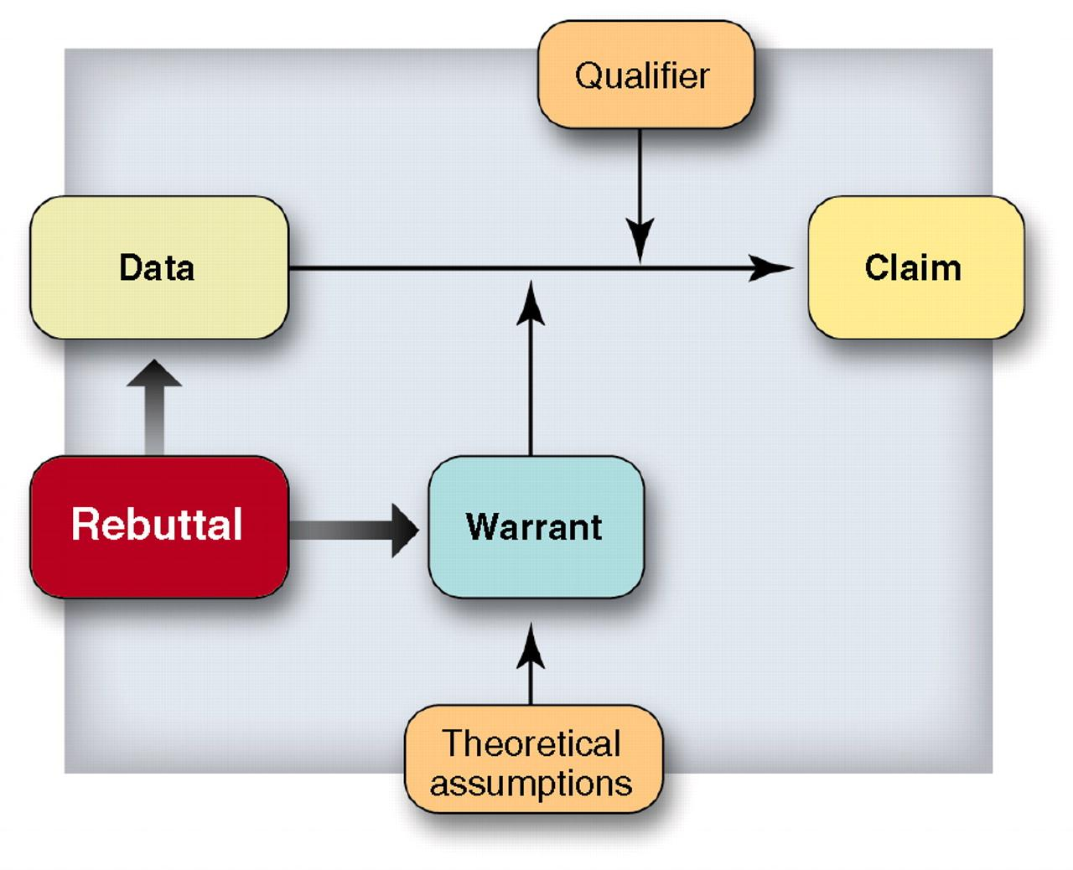
http://www.nsta.org/pdfs/ngss//201204_Framework-ReiserBerlandKenyon.pdf

Scientific Argumentation as a Foundation for the Design of Inquiry-Based Science Instruction. Falk & Brodsky. http://www.math.vcu.edu/g1/journal/Journal_13/4_Falk_Brodsky.pdf

Arguing to Learn in Science: The Role of Collaborative, Critical Discourse. Science 23 April 2010: vol. 328 no. 5977 463-466

1. Learning the Vocabulary with Reason Racer
Scientific argumentation helps you use evidence and reasoning to evaluate and make judgements about a claim. Combining car races and interactive pit stops, Reason Racer helps students practice the process of identifying and evaluating `claim statements, so they can think like scientists! Over 40 scenarios were designed by ALTEC, a division of the Center for Research on Learning at the University of Kansas to tap into the engaging power of collaborative online gaming for learning.
*Internet willing, we will all take a spin around the racetrack and experience the components that make up scientific argumentation!

2. Practice Real Life Via Social Media
Where students love to be now and where they will no doubt be later on in life. We need to teach them How to Cross the Digital Street:
- Voxxi - http://www.voxxi.com/social-media-schools-curriculum
- Innovative Educator Blog: Why Social Media Curriculum is Critical

Scientific Argumentation via Social Media:
9th Grade Biology Inheritance Unit
- Chromosome Challenge - students uploaded image and summary of group hypothesis, critiqued the explanation of another group
- Mitosis/Meiosis Flipped Lesson - students tweeted/posted while watching the video and answered questions that were posed in the video.
- Argumentation Introduction (AEG) - students read a 1-page article on autism and vaccines and posted thoughts on social media. Social media was used to review content from the previous day.
- Baby Lab - students shared picture of their ideal mate via social media.
- Genotyping/Bucket of Disease - students posted most interesting fact they learned about the disease they drew.
- Puzzling Pedigrees - Students posed their pedigree puzzle on social media within schools to solve. Class voted on most interesting or toughest puzzle and put it up for another school to solve.

Project Teachers to follow on Twitter:
- Kelly Williams: @williams_nvhs
- Lisa Ball: @msball_lhs
- Julie Schwarting: @msschwarting
- Jeremy Mohn: @JeremyMohn

Twitter Integration Ideas:
- Twitter handle for Kelly Williams, Biology Teacher at Nemaha Valley HS: williams_nvhs and his Google Site/blog with information about flipped teaching: https://sites.google.com/a/usd115.org/nv-science/home/what-s-happening-in-mr-williams-classroom
- Organellewars:
http://www.plantcellbiology.com/2012/10/the-organelle-presidential-campaign-2012/
and
http://drmolecule.files.wordpress.com/2012/10/organellewars-cell-organelle-campaign.pdf
- Video Reflections
- Brainstorming carcinogens
- Find, follow and tweet with experts (e.g. Google “scientists to follow on twitter”)
Other Social Media Platforms
- Edmodo
- FaceBook
- Blogs (i.e. Wordpress) Sample Blog from Jeremy Mohn
- Wikis (i.e. Wikispaces) Sample Jana’s Wiki for TIME
- Aspects of Learning Management Systems (i.e. Blackboard Collaborate, Moodle, etc)
*Talk to your neighbor about how you could engage Twitter or other social networks in your teaching/work. Post to the conference hashtag: #gbtech13

3. Reach Beyond Classroom Walls with SKYPE
https://education.skype.com
*Run a search at SKYPE in the classroom for a lesson you could use or a teacher you could connect with. When you’re done, you can sign-up for a free group SKYPE account as an educator!

4. Brainstorm, Question, and Provide Evidence in Padlet
http://padlet.com/jana314/vh8yab1yhmkp
*Go to the Padlet wall link above and provide evidence to support or challenge my claim.

5. Collaborate and Share Using Google Drive
*Add your plan or strategy for increasing argumentation and collaboration for student learning below:
- I will have my students play Reason Racer to help them gain confidence with the vocabulary used in Scientific Argumentation.

