Ten Reasons to Install the Strategic Instruction Model (SIM) in Your School

#1 Empirical Validation
Empirically validated in bona fide research experiments in schools under typical school conditions. KU-CRL’s effect sizes are derived from studies with tremendous variability; however, the center has produced remarkable consistency given those contexts including:
- Studies conducted in middle schools and/or high schools
- Extra period of reading and no extra period for reading in the same study
- Some multiple year studies, and others not
- Schools settings range from inner-city to rural
- Studies took place across the U.S.
https://www.huffingtonpost.com/entry/the-rapid-advance-of-rigorous-research_us_5880cfb3e4b0fb40bf6c470e
You can read a description and a research summary for each strategy or routine here: https://sim.drupal.ku.edu/sim-curricula

#2 Outside Validation
Listed on educational websites (IES/NCEE) as meeting certain important criteria.
“However, unlike small and quasi-experimental studies, rigorous experiments using standardized outcome measures replicate. These effect sizes may not be enormous, but you can take them to the bank….In our secondary reading review, we found an extraordinary example of this. The University of Kansas has an array of programs for struggling readers in middle and high schools, collectively called the Strategic Instruction Model, or SIM.” ~ Robert Slavin, Johns Hopkins Univ.
https://sim.drupal.ku.edu/sim-news
https://files.eric.ed.gov/fulltext/ED560732.pdf https://ies.ed.gov/ncee/pubs/20164001/

#3 Clear Overall Goals
The strategies and routines each contain specific goals for student outcomes. They are written to support students as they work to meet the demands of their regular coursework, succeed in high school, and succeed in a post-secondary educational program. The University of Kansas Center for Research on Learning (KUCRL) has been working to improve the lives of learners who struggle since 1978. We have shared some of the ways in which our work has changed lives for the better. These are your stories as well as ours.
https://sim.drupal.ku.edu/impact

#4 Instructors’ Manuals and Guidebooks
- Each Learning Strategy and Routine has an instructor’s manual that contains step-by-step instructions on how to implement it with a focus on empowering students to be active learners who learn to monitor their own learning and progress.
- The manual can be used by administrators to support teacher’s use with fidelity for optimal results.
- A common vocabulary is used across all manuals.
- Executive skills and metacognitive processes are built in for students and teachers to learn and develop.
- Modeling and generalization across school and world settings are at the heart of the instruction.
https://sim.drupal.ku.edu/learning-strategies
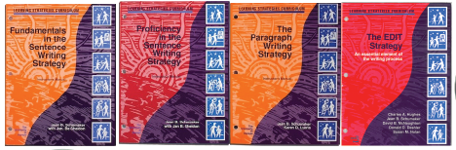

#5 Student Materials
- Clear directions in Instructor’s manuals explain how to provide all levels of practice and generalization.
- Sometimes materials are included in the instructor’s manual.
- Sometimes materials are available in a separate book or on the Internet.
- Often, leveled materials at schools can be used.

#6 Quantifiable outcomes
- Each Learning Strategy provides at least one quantifiable measure of student performance so that outcomes can be measured.
- A pretest and a posttest are provided related to the skills taught in the curricula.

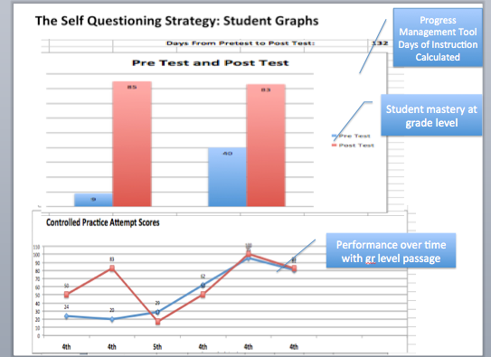

#7 Gains
- Teachers, students, and administrators see real gains in student performance, gains that affect the quality of students’ lives, such as:
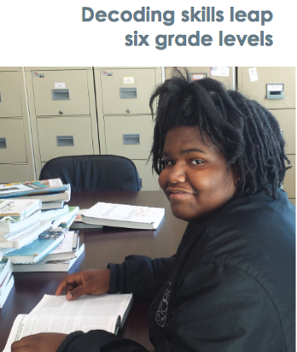
  - Improvements in grades,
  - Attendance, and
  - Graduation rates
- Feedback undergirds each step so students and teachers recognize progress.

When I was in 10th grade, I learned how to use the SIM Strategy of Word Identification in the spring. It helped me sound words faster, and I read quicker. I use the strategy in English, Math, and Social Studies. I now learn by reading. ~ Jarquis

#8 Versatile Usage
Depending on their purpose in your system,
- They can be used with various types and ages of students, individuals, small groups, and large groups.
- A variety of educators can use them successfully.
- Beyond school day, scheduled classes, summer school, tutoring are all examples of appropriate settings for use.

#9 Clear Data for Decision-making
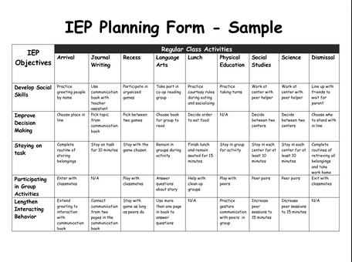
- The curricula provide student data for IEPs, 504 plans, placement decisions and student match for support.
- The curricula provide teacher data for mastery.

#10 Focus on Literacy
- The curricula can be used to build a school-wide focus or programmatic focus.
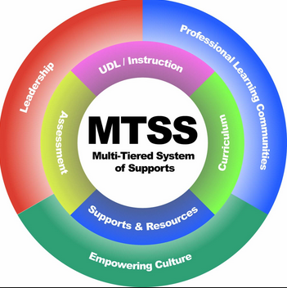
- The curricula address all Tiers.

