SIM™ Specialist in a Learning Strategy
A Checklist for Level 3 of Micro-credentialing

This checklist encompasses the evidence needed for completion of Levels 1 and 2, allowing a teacher to jump directly to the completion of Level 3, SIM Specialist.
Upload the following items to the Badge List website: https://www.badgelist.com/SIM-Learning-Strategies

Evidence for Level 1: Professional Learning (PL)

- Date of participation in initial professional development: _________
- 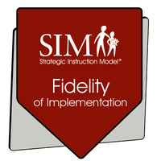Reflection (optional)

Evidence for Level 2: Fidelity of Implementation (FI)
- Names of SIM Professional Developer(s) with whom the teacher has a coaching relationship: _________________________________
- “Teach the Strategy”: Provide dates of implementation and a statement that you taught the Learning Strategy in its entirety.
- Portfolio of Implementation (a narrative log of implementation experiences and coaching experiences)
- Video of instruction with self-reflection using LS implementation checklist OR feedback form (a.k.a. implementation checklist) from a class visit by SIM Professional Developer. The lesson for this video or class visit should include the Model Stage or Learn-by-Watching Approach.
- Student Portfolio (strategy folder)
- 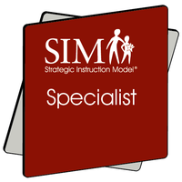Student interview (optional)

Evidence for Level 3: Specialist (SP)
- The items under FI appear under this category also. You can make a statement that refers to the evidence provided until the FI micro-credential rather than re-posting/uploading.
- Instruct a Teacher:
  - Feedback from SIM Professional Developers on LS PD provided
  - Evidence of LS PD provided (agenda and Power Point)
- Describe your Instruction: written description or answer provided questions regarding your experience in providing coaching to another teacher. Post a progress chart from the other teacher’s class.
- Describe Implementation: answer questions regarding the instruction in another teacher’s class for whom you have provided coaching.

For more information on the requirements for each item, please visit the Badge List website or inquire with your SIM Professional Developer.

