Hoxie provides implementation analytics for schools and districts working with the Content Literacy Continuum®. With Hoxie, you can:

 | • | Collect and evaluate real-­‐time classroom walkthrough data
 | • | Manage and analyze instructional coaching activity
 | • | Review implementation patterns within your school

In Hoxie, we’ve merged our mobile data collection tools and our instructional coaching scheduling and analysis tools into a single system. No need to manage multiple logins and bookmarks on your computer! The following tools are all available under one roof:

Walkthroughs | Collect walkthrough data, analyze and discuss it through sophisticated visualization techniques, and export it for further analysis.
SIM Collections | Capture evidence of classroom SIM usage via collections, and export collection data for further analysis.
Coaching | • Teachers can schedule time with an instructional coach at their school, and review past appointments with coaches.  • Coaches can manage their coaching schedule, record unscheduled coaching, and review coaching activity.  • Site Leaders can access and analyze coaching activity at their school.
Self-­‐Reports | New for the 2013-­‐2014 school year, this feature allows teachers to show off their hard work in the classroom by reporting which devices have been put in place.

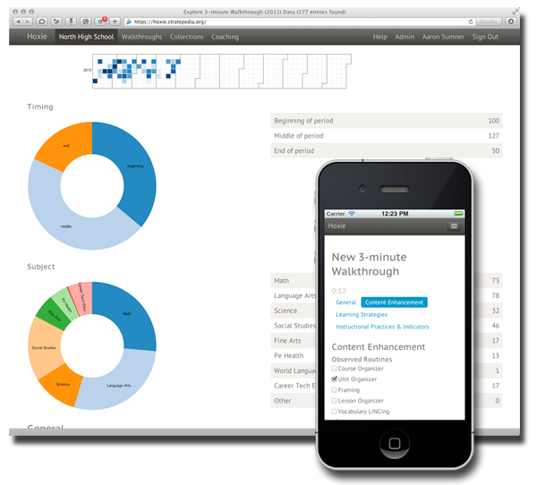We’ve also developed Hoxie with your handheld or tablet in mind. Hoxie looks as great on a modern smart phone or tablet as it does in a modern web browser on your computer. Hoxie works well in older web browsers, but it shines in the latest versions of Safari, Chrome, Firefox, and Internet Explorer.

What is the cost? $500 per year. This includes setup, support, and hosting for up to 10 schools.

Check out Stratepedia.org or email us at help@stratepedia.org for more information.

Hoxie is a product of the University of Kansas Center for Research on Learning, developed by the Stratepedia team. The Content Literacy Continuum is a registered trademark of the University of Kansas Center for Research on Learning.

