**Acceleration with SIM Note Catcher**

**Questions we will explore:**

* What is acceleration and why is it needed?
* What do teachers need to think about in planning for acceleration?
* How can the SIM SMARTER Instructional Cycle & Content Enhancement Routines support acceleration?

**Characteristics of Acceleration:**

Notes:

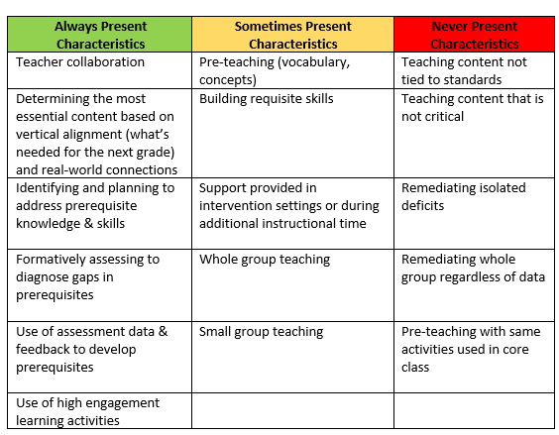

**Examples & Nonexamples of Acceleration:**

Notes:

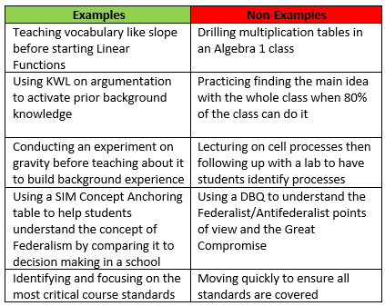

**Why is acceleration challenging and what do teachers need to think about in planning for it?**

Notes:

**SIM SMARTER Instructional Cycle**

Notes:

* **S**hape critical questions aligned with standards
* **M**ap critical content and relationships
* **A**nalyze critical content & relationships for learning challenges
* **R**each instructional enhancement decisions
* **T**each strategically
* **E**valuate learning
* **R**evisit learning outcomes and critical questions

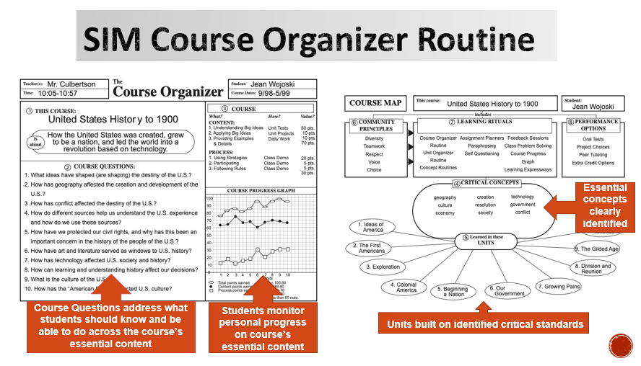**Course Organizer and Acceleration**

Notes:

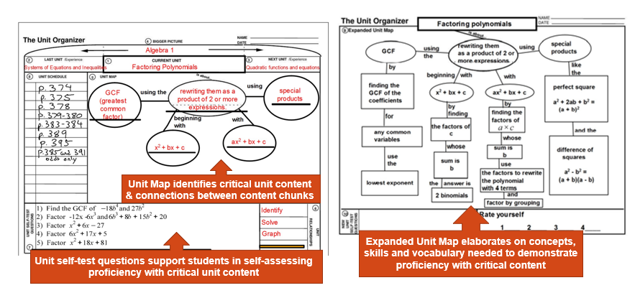**Unit Organizer and Acceleration**

Notes:

**Other CERs that can support acceleration:**

Notes:

**Reflection: How might you approach a teacher, group of teachers, school or district who is focusing on acceleration?**

Notes: