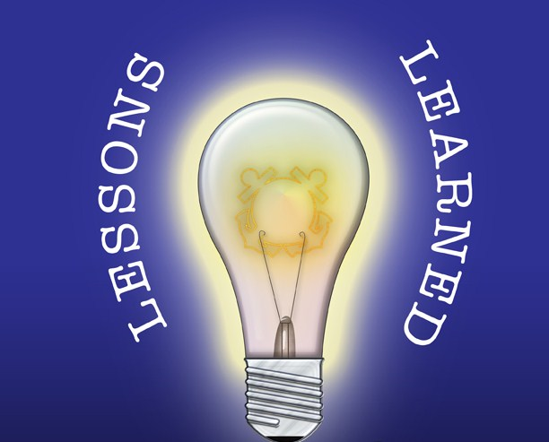

**North Carolina Content Literacy Continuum™ Project**

Lesson #1: Create a Common Vision:

* Listen closely to others and enlist their input in the creation of the shared vision.
* Determine effective ways to deliver a consistent message.
* Use the common vision as a launch pad for the creation of solid goals and action plans.

Lesson #2: Build Structures of Support:

* Develop effective teaming structures and depict those on a detailed organizational flow chart.
* Establish communication plans that promote a two-way flow of information.
* Design a robust plan for professional development, coaching and mentoring.

Lesson #3: Identify and Foster Connections:

* Take time to understand the system/organization that is undergoing the change.
* Recognize other current initiatives and connect the work to them.
* Build positive working relationships.

Lesson #4: Build Capacity:

* Identify individuals who exhibit potential and recruit them to assume leadership roles.
* Be prepared to address shifts in key personnel.
* Take advantage of the micro-credential system of certification.

Lesson #5: **DON’T GIVE UP!**

“Improvement seldom, if ever, occurs on a straight trajectory; it typically involves bumps and slides, as well as gratifying leaps.”

*School Reform from the Inside Out: Policy, Practice, and Performance*

by Richard F. Elmore

