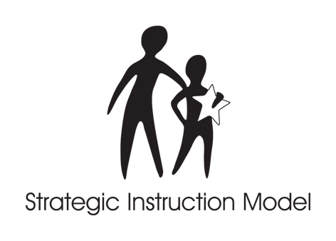

STRATEGIC INSTRUCTION MODEL™

SIM for Administrators
June 22-24, 2011
Instructed by Rosalind Davenport

DAY ONE
8:00-8:30 a.m. Registration
Overview of SIM
Adolescent Literacy
Lunch on your own
Adolescent Literacy
The Framing Routine

DAY TWO
8:30 a.m, The Content Literacy Continuum
The Big 4 of Instruction
Change and Systems
Lunch on your own
Building Capacity/SIM as a connector
Question Exploration Routine

DAY THREE/Half Day
8:30 a.m Instructional Leadership &
Administrative Leverage
SMARTER Planning & Instructional Leadership Plan
Noon Adjourn OR Lunch
Optional afternoon session with teachers completing
Content Enhancement course

