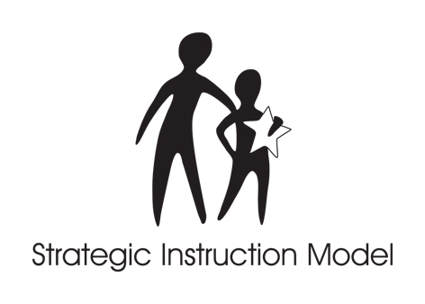

STRATEGIC INSTRUCTION MODEL™

SIM for Administrators
June 23-25, 2009
Courtside Room of the Burge Satellite Union
Instructed by Rosalind Davenport and Cathy Spriggs

Wednesday
8:00-8:30 a.m. Registration
Overview of SIM Courtside Room
Unit Organizer Relays Room
Lunch on your own
Adolescent Literacy Courtside Room
Content Literacy Continuum

Thursday
8:30 a.m, The Big 4 of Instruction Courtside Room
Change and Systems
Lunch on your own
Administrators as Instructional Leaders
Partnership Learning and SIM

11:30 a.m. Turn in any manual orders; Include Credit card info on order form if using credit card; Do not pay money. Do not write checks until Thursday

Friday
8:00-8:30 a.m Pickup and Pay for orders from EDGE and CRL
FRAME Courtside Room
Instructional Leadership Plan
11:30 a.m. Manual Orders delivered
Noon Adjourn OR Lunch
1pm Optional: Gallery Walk: Integration of Routines and discussion/debrief with teacher/educator participants in Content Enhancement Level 1.

