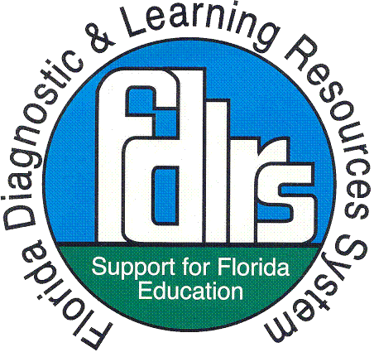

**SIM LS Specialist Mentor Checklist**

***To ensure that each potential specialist has a strong likelihood of completing the specialist micro-credential requirements.***

**Identifying a Potential Specialist:**

1. Verify that the potential specialist has implemented and is skilled in the targeted Learning Strategy with the following evidence (must meet 80% or more of the criteria on each checklist):

* Completes a *Portfolio of Implementation* in which they:
* Describe the group or student (size of group, level, student characteristics, etc.)
* Describe the length of implementation (weeks or months, amount of time per day, days per week)
* Submit student progress chart(s) without student names
* Submit a narrative log of implementation experiences (what went well and/or poorly, adjustments made if necessary, ideas generated for issues encountered, and impact)
* Submit a narrative describing coaching, feedback, and follow-up, identifying their coach
* Can satisfactorily answer the Frequently Asked Questions
  1. What would you say to a teacher who says, “I would like to teach strategies, but I don’t have time.”?
  2. What would you say to a teacher who says, “My students really need to use the learning strategies class period to study.”?
  3. How would you explain SIM Learning Strategies to an administrator or parent?
* Captures a video showing their competence in modeling the strategy. The video must show the entire model. Provide feedback using the Modeling Video Evaluation Checklist of Critical Teacher Behavior.
* Completes a Model Video Reflection Sheet and shares it and the video with you during a debriefing session.
* Compiles a Student Portfolio that shows complete implementation of the strategy (with identifying information removed). Use the Student Folder Checklist to provide feedback.

1. Verify that the potential specialist has the skills needed to be a quality Professional Developer including a positive attitude and the desire and temperament to teach adults
2. Review the **LS Specialist Micro-Credential Checklist** with the potential specialist and verify that he or she understands the requirements and has the time to commit to the credentialing process

**Mentoring a Specialist Through Micro-credentialing:**

1. Ensure specialist micro-credential has been purchased (SPDG SIM Project Participants, please contact Janice Creneti, [crenetij@pcsb.org](mailto:crenetij@pcsb.org) ).
2. Work with the potential specialist to set-up an “Instruct a Teacher” session for one or more teachers. Plan to attend in person or have the potential specialist video the session. Support their planning and ensure they have needed information to complete reporting requirements including:
   * Sign-in sheet
   * Session agenda
   * FDLRS SIM Workshop Evaluation Survey
   * Student Outcome Data submission requirements
   * FDLRS Center Contact Information
3. After the potential specialist has provided an “Instruct a teacher” session, debrief with the potential specialist using the LS Specialist Micro-Credential: “Instruct a Teacher” Session Checklist and the LS Specialist Micro-Credential: “Instruct a Teacher” Session Reflection Form
4. If the potential specialist shows at least 80% mastery as measured by the LS Specialist Micro-Credential: Specific Presentation Checklist, have them upload evidence to the SIM Micro-credential website <http://sim.kucrl.org/micro-credentials>
5. If the potential specialist did not meet mastery, provide coaching, and assist them in setting up another “Instruct a Teacher” session…repeat the process.

Support the potential specialist in asking participants to submit student outcome data on <http://www.fdlrs.org/statewidepd/sim.html>. Also provide support to ensure that the FL SIM Professional Development Information Survey is completed on this same site.

1. After the teacher(s) in the “Instruct a Teacher” session has implemented, support the potential specialist in debriefing with the teacher using the following (or similar) questions:
   * + What were the successes?
     + What were the challenges?
     + How can address the challenges together?
2. Notify KUCRL at [simpd@ku.edu](mailto:simpd@ku.edu). Provide the date awarded and two or three statements about why you have awarded this credential to this learner. These statements will be attached to the learner’s credential, including your name as the awarding SIM Professional Developer, and may be viewed by the public.
3. ? Who should be notified in Florida when the Specialist is awarded?