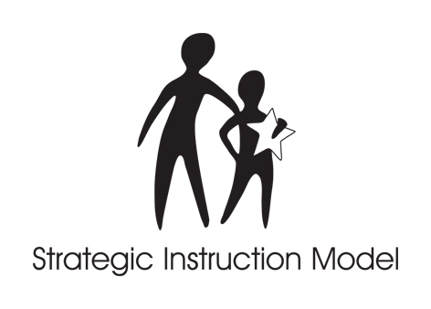

STRATEGIC INSTRUCTION MODEL™

INTRODUCTION to CONTENT ENHANCEMENT
June 24-27, 2008
Courtside Room of the Burge Satellite Union
Instructed by Rosemary Tralli

AGENDA

DAILY SCHEDULE
8:00-8:30 Welcome Activities
8:30-11:30 a.m. Class
11:30-1:00 p.m. Lunch
1:00p.m.-4:00 p.m. Class

Tuesday
Overview of Content Enhancement
Unit Organizer Routine
Framing Routine

Wednesday
Overview of Content Enhancement
Concept Mastery Routine
Concept Comparison Routine
GIST
Turn in any manual orders; Include Credit card info on order form if using credit card; Do not pay money. Do not write checks until Thursday

Thursday
Overview of Content Enhancement
Course Organizer
Clarifying Routine
Pickup and Pay for orders from EDGE and CRL

Friday
Question Exploration Routine
Next Steps
Adjourn by noon

