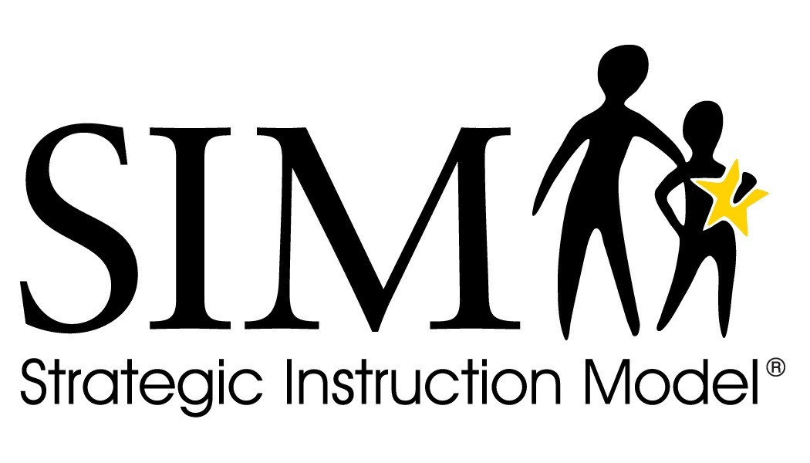
SIM Leadership Award
This is your opportunity to recognize a certified inservice or preservice professional developer for her/his outstanding contributions and efforts associated with SIM and the SIM Network. This award is for individuals who have shown leadership and excellent service to SIM by helping educators to become strategic teachers and consequently, aiding students to become strategic learners. Your nominee should be an active member in the SIM Network who regularly attends update sessions, subscribes to Strateworks and shares knowledge with other members of the network via Stratenotes, professional development reports, SIMville, Simtrainer-l, or presentations at national, regional or state conferences.
SIM Administrative Leadership Award
This award is designed to honor a person who is associated with the SIM Professional Developers’ Network and who serves in an administrative position in a school or school district. The award recognizes individuals for outstanding leadership and contributions in promoting SIM and other research–based practices.
SIM Impact Award
The SIM Impact Award is presented to schools or school systems that have widely adopted many components of the Strategic Instruction Model throughout major segments of their entire school system and have carefully gathered data related to their efforts.
SIM Initiative Award
KUCRL is excited to announce a new award! The SIM Initiative Award has been created with regional SIM Updates in mind for an opportunity to celebrate regional accomplishments. It will be given to individuals or teams that have demonstrated determination, creativity, resourcefulness, and vision in providing students with the opportunity to benefit from the Strategic Instruction Model.
Know someone outstanding? Nominate them today!
Your Name and email: _____________________________________________________________________
Nominee:
Award Nominated for:
Nominated by:
Reason for Nomination:

