PLANNING |  | Planning Notes (answers to questions) |  | Materials/Resources Needed
Shape the critical questions | - What are the critical learning outcomes for all students in this course or unit?  - How can critical questions be formulated to measure the intended outcomes for all students?  - Out of all the information that might be learned, conceptually, what are the central or “big” ideas that tie all of this information together?  - Which standards (state and local) are being addressed?  - How will the questions help me to engage in more student-centered learning?
Map the critical content | - How will the information be mapped and sequenced so all students understand it? (limiting, connected, linear, hierarchical, labeled, simple)  - What are the essential pieces (important ideas, concepts, or information) for this unit?  - What is the paraphrase of the “big ideas” of this unit?
Analyze for learning difficulties | - Which, if any of these pieces, will be challenging for any of the students?  - What are the strengths and difficulities (academic and behavioral, social) identified for SWD and students at-risk?  - What background knowledge will students need to profit from this unit?
Reach enhancement decisions | - Which devices and evidence-based practices will be most beneficial, effective and efficient to use with students? (to graphically organize information, explore conceptual knowledge, or understand recurringrelationships)  - What additional activities, labs, projects, etc. will be implemented to support the learning in this unit?  - What accommodations or options will be made available for some or all students?  - How much time is needed for instruction in SIM LS in this unit?
TEACHING |  | Planning Notes (answers to questions)
Teach strategically | - How will I provide informed instruction?  - Do I explain, show and model for students how information will be taught and learned on an ongoing basis? CUE  - Do I work with students and support learning partnerships to arrive at learning outcomes? DO  - Do I communicate the value of learning how to learn to students through the use of ongoing evaluation and feedback? REVIEW
ASSESSING |  | Data Points to Collect | Planning Notes (answers to questions) |  | Next Steps
Evaluate mastery | - Did all students achieve the intended outcomes?  - How well were my planning and teaching outcomes met? (How effective was a device, did I spend enough time developing the routine; what do I need to do differently next time?)  - Was there enough time provided for SIM LS instruction?  - What formative assessments need to be in place to provide feedback to students to accelerate learning?
Revisit outcomes | - Did all students reach the intended learning outcomes?  - If students did not reach the intended outcomes, what are the next steps?  - How is evidence of performance recorded for all students?  - Did I choose the most critical concepts and information? If so, how will I reteach for mastery? If not, will I abandon the outcome?

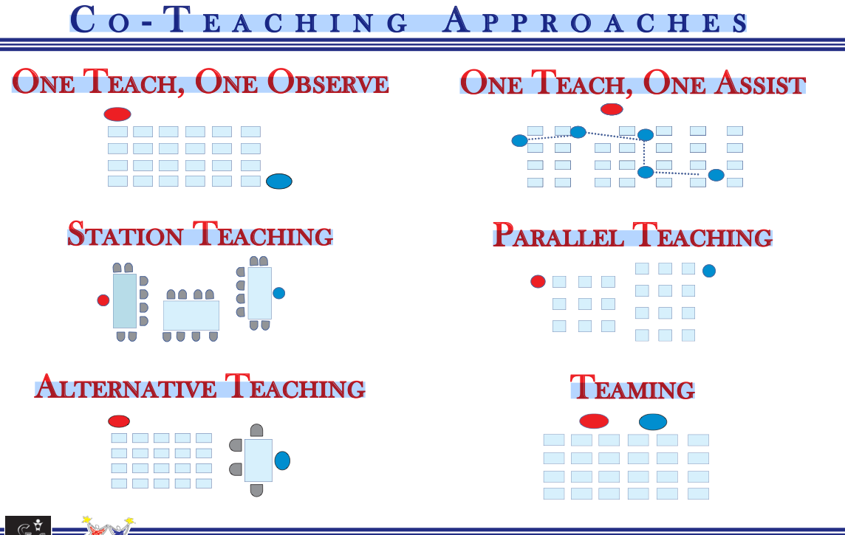 Co- Teaching Approaches with Descriptions Listed in Order of Recommended Frequency
- Parallel Teaching- Teachers are both using the same information, but they divide the class into equal groups and teach simultaneously.
- Station Teaching- Teachers divide content and students. Each teacher then teaches a portion of the content to one group and subsequently repeats instruction for the other group. An additional station can give students opportunities to work independently, access peer tutoring, or technology,
- Teaming- Both teachers are delivering the same instruction at the same time. Most consider this approach the most complex but satisfying way to co-teach.
- Alternative Teaching- One teacher takes the responsibility for the large group while the other works with a smaller group. The smaller group is not a permanent subset of the class and can be pulled aside for preteaching, enrichment, tiered intervention, to develop a special activity to present to the remainder of the call, or for presentation of content using an alternative method or strategy.
- One Teach, One Observe or Support- One teacher manages instruction of the entire class while another teacher systematically gathers data on a previously agreed upon item. This is to be used only 5-10% of the class period.
- One Teach, One Assist- One person takes primary responsibility for teaching the content of a lesson while the other professional circulates through the room providing unobtrusive assistance to students as needed.

dgillam@ku.edu 2017

