LINCS Tables

1 Term

3 Reminding Word

4 LINCing Story
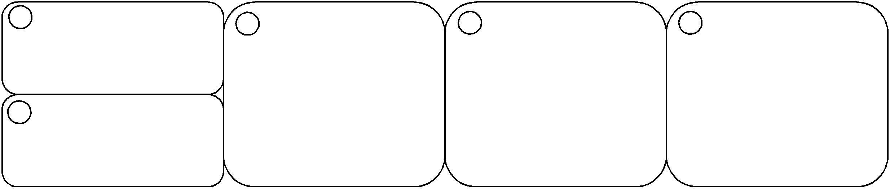

5 LINCing Picture
2 Definition

1 Term

3 Reminding Word

4 LINCing Story
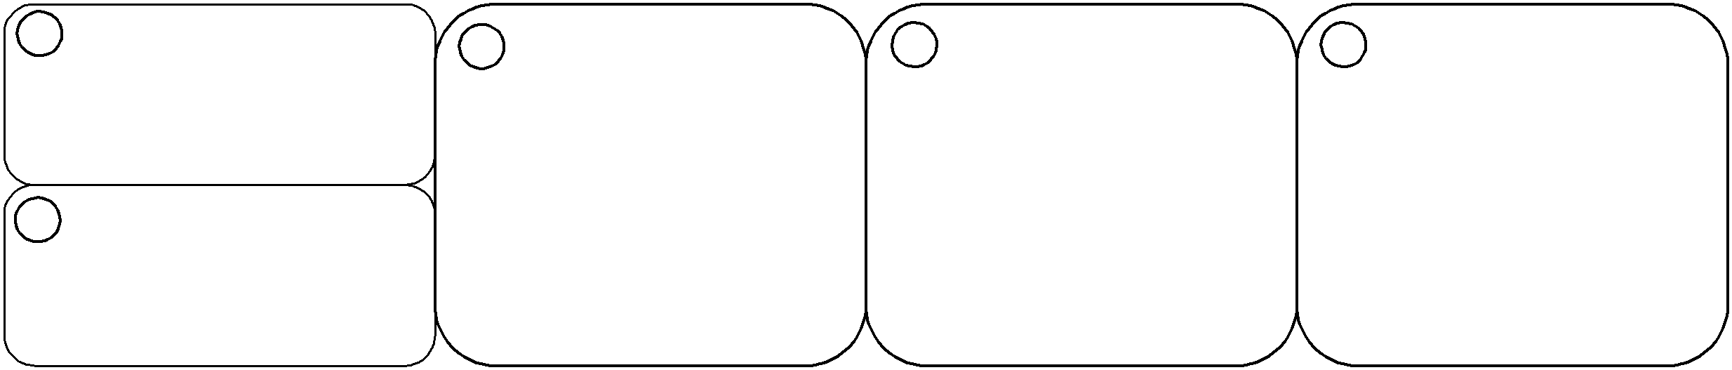

5 LINCing Picture
2 Definition

1 Term

3 Reminding Word

4 LINCing Story
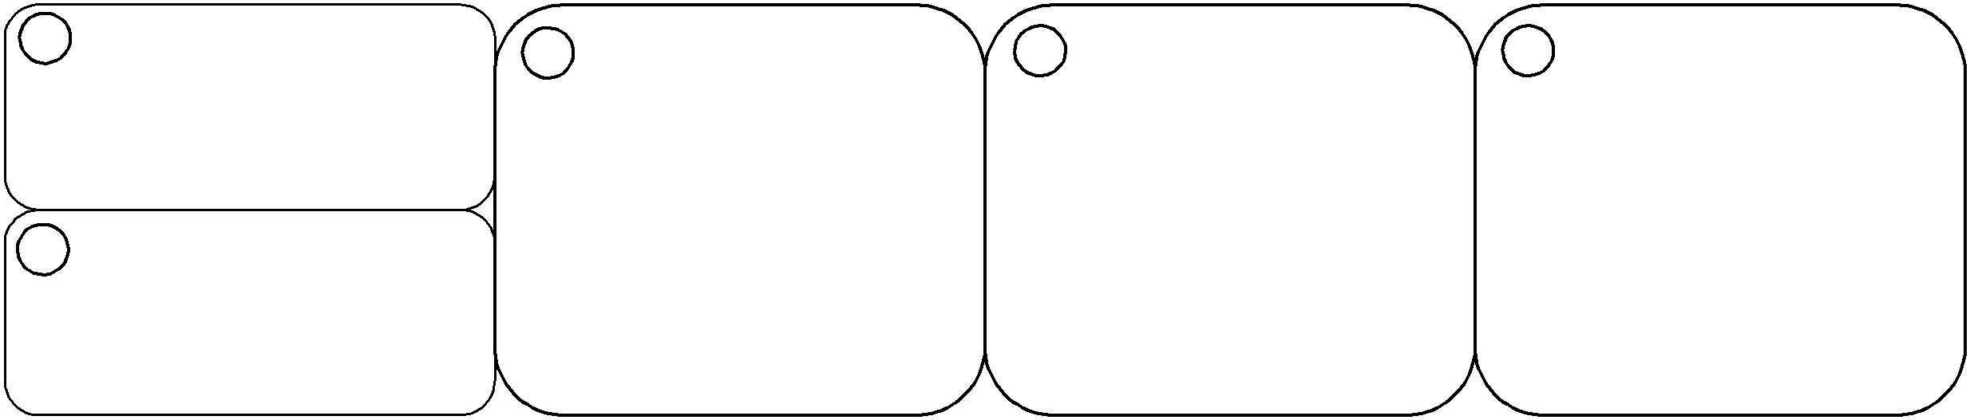

5 LINCing Picture
2 Definition

1 Term

3 Reminding Word

4 LINCing Story
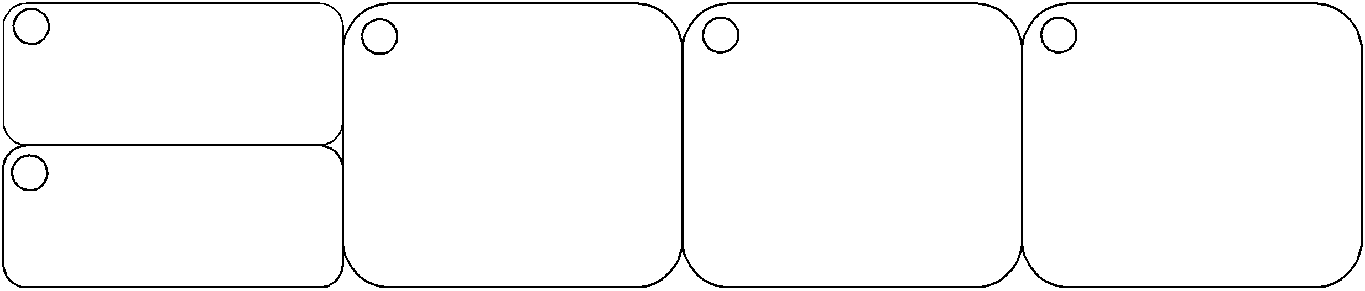

5 LINCing Picture
2 Definition

List the parts Identify a reminding word Note a LINCing story Create a LINCing picture Self-test

